Ashcon Abae

CMSC 405 7981

15 December 2019

Project 4

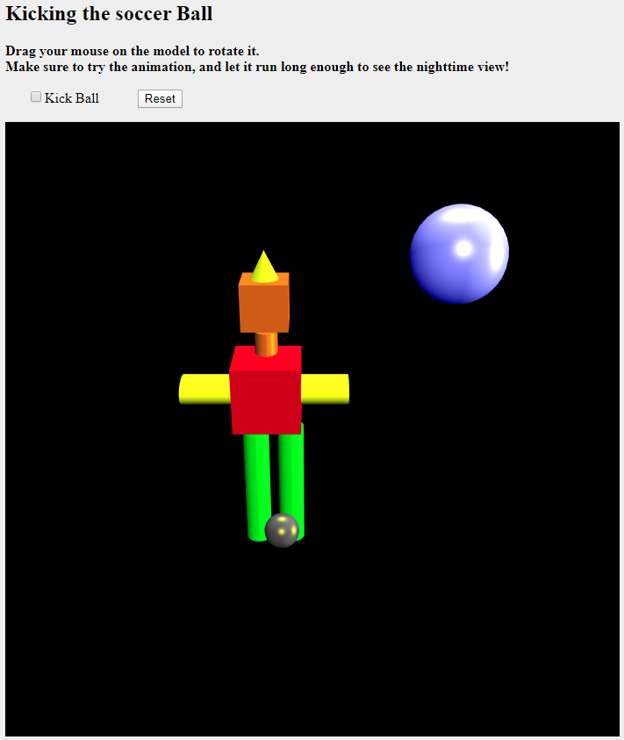  
Figure 1: A screenshot of my unique animation

In Figure 1 above, we can see a screenshot of my WebGL animation. At a brief glance, we can count 10 different WebGL objects: a moon in the top right, a person made of 8 components (a hat, a face, a neck, a torso, 2 arms, 2 legs), and a soccer ball. There is a radio button at the top that plays, pauses, or resets and stops the animation. To verify that my program is working as expected, my test plan involves comparing my program to the specific requirements indicated in the project description.

1. **Size: minimum 640x480**  
     
   In this screenshot, we can see that our WebGL canvas is 700x700.
2. **Includes at least 10 different objects**  
   As we saw in Figure 1, our animation includes 10 different objects:
   1. A sphere representing a moon in the top right
   2. A cone representing the person’s hat
   3. A cube representing the person’s face
   4. A cylinder representing the person’s neck
   5. A cube representing the person’s torso
   6. 2 cylinders representing the person’s left and right arms
   7. 2 cylinders representing the person’s left and right legs
   8. A soccer ball at the person’s feet
3. **Uses multiple lighting effects on different materials**  
   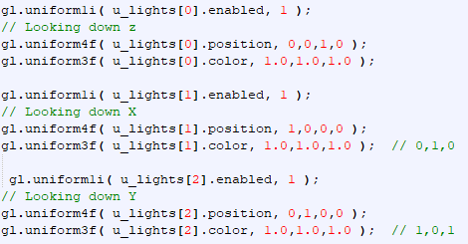……  
   In this screenshot, we can see 3 different lighting effects being used on 2 different materials.
4. **Uses multiple textures**  
   As we saw with the different materials, we can see that these different materials have different textures, which is part of the reason why lighting affects them differently.
5. **Includes radio buttons, slider bars, or other widgets to turn on or off certain components of the animation**  
     
   In this screenshot we can see 1 radio button that pauses/plays the animation when unchecked/checked, respectively. Additionally, we can see a reset button that stops and resets the animation to initial positions, including the camera perspective.
6. **Uses frame buffers to organize the memory resources that are needed to render the scene.**  
     
     
   In this screenshot we can see the clear and clear color methods used to affect rendering in whichever frame buffer is current. Additionally, we can see more buffers below:  
     
   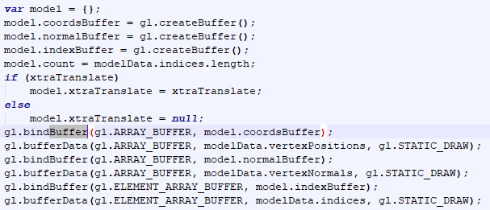
7. **Uses WebGL**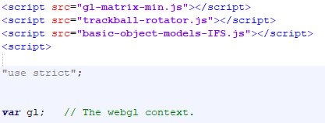  
     
   In this screenshot we can see the some of the necessary components of WebGL we are using.